

**PROJECT NAME: TABLES & CHARTS MANAGEMENT SYSTEM**

**CSE303,SECTION 2, GROUP 1**

**PROJECT COMPLETED BY**

|  |  |
| --- | --- |
| **Name** | **ID** |
| Mohammad Masum Hossain | 1810691 |
| Syed Fazlay Rob Shabok | 1921740 |
| Md Nakibul Islam | 2022142 |
| Zarin Tasnim | 1731638 |
| Razia Tajrin | 1710734 |

**COURSE CO-INSTRUCTED BY:**

Ms. Nujhat Nahar

Ms. Sadita Ahmed

Mr. Abu Sayed

**CONTENTS**

**CHAPTER 1- INTRODUCTION…**…………………………………………………………… 3

**A.BACKGROUND OF THE ORGANIZATION -IUB**……………………………………….. 3

**B. BACKGROUND OF THE PROJECT**…………………………………………………….. 3

**C.OBJECTIVE OF THE PROJECT** …………………………………………………………. 4

**D. SCOPE OF THE PROJECT** ………………………………………………………………. 4

**CHAPTER 2 - REQUIREMENT ANALYSIS** ................................................................... 5

**A. RICH PICTURE - EXISTING BUSINESS SYSTEM** ………………………………….... 5

**B. SIX ELEMENT ANALYSIS- EXISTING BUSINESS SYSTEM** ………………………... 6

**C.PROCESS DIAGRAM** ……………………………………………………………………… 7

**D. PROBLEM ANALYSIS-EXISTING BUSINESS SYSTEM**……………………………… 8

**E. RICH PICTURE - PROPOSED SYSTEM**………………………………………………… 9

**F. SIX ELEMENT ANALYSIS - EXISTING BUSINESS SYSTEM**………………………… 10

**G. PROCESS MODEL - PROPOSED SYSTEM**…………………………………………… 16

**CHAPTER 3- LOGICAL SYSTEM DESIGN** ……………………………………………….. 19

**A. BUSINESS RULES**………………………………………………………………………… 19

**B.ENTITY RELATIONSHIP DIAGRAM**……………………………………………………... 21

**C.ENTITY RELATIONSHIP DIAGRAM TO RELATIONAL SCHEMA**………………….. 22

**D. NORMALIZATION**…………………………………………………………………………. 23

**E. DATA DICTIONARY**………………………………………………………………………... 28

**CH-1 INTRODUCTION**

## BACKGROUND OF THE ORGANIZATION

Founded in 1993, Independent University, Bangladesh is one of the oldest private universities in Bangladesh where academic excellence is a tradition, teaching a passion and lifelong learning a habit. IUB currently has more than 7,048 undergraduate and graduate students and over 10,455 alumni. The student population is projected to grow at 10% annually. The students of IUB experience an exciting academic life with copious opportunities to explore and nurture their innate talent.

IUB uses smart and new techniques of education which are robust and is committed to produce graduates who will be equipped to provide new leadership through skilled employment.

## BACKGROUND OF THE PROJECT

The goal of this project is to create a web-based system that will enable a university to make meaningful analysis of its resources and revenue in the form of tables and graphs. The system will have the capability to calculate IUB classroom requirements as per course offering, enrolment-wise course distribution among the schools, revenue, and much more.

It will provide a range of tools intended to help universities and other stakeholders to evaluate its resources and revenue and provide strategies for improvements.

## OBJECTIVES OF THE PROJECT

The main purpose of creating this system is to reduce the amount of work and make the work more orderly. The university has a lot of work that takes a lot of time to do, like if we want to see how many classrooms the university has, how many have been enrolled in different departments and how much money the university has been able to generate revenue and the difference in departmental revenue. This kind of work requires a lot of time and a lot of calculations but the system we are building will show all this information in the form of tables and charts in a few moments so that it will take a lot of time and make the work much easier. Will be done.

## SCOPE OF THE PROJECT

In the existing system all the data that is required for making meaningful analysis of concerns such as Resource Usage or Classroom Requirements among other topics for each semester is done manually. For each type of data employees have to tediously reach out to different offices and departments and then use those data to make necessary calculations by hand.   
  
All this inconvenience can be avoided by implementing a centralized database from which all the required data can be downloaded at once in the form of tally sheets. The tally sheets can then be uploaded into a system that can extract all the data from it and make required calculations using those data to automatically generate meaningful tables and graphs as per user requirements.

**CH-2: REQUIREMENT ANALYSIS**

## EXISTING BUSINESS SYSTEM (WITH RICH PICTURE)

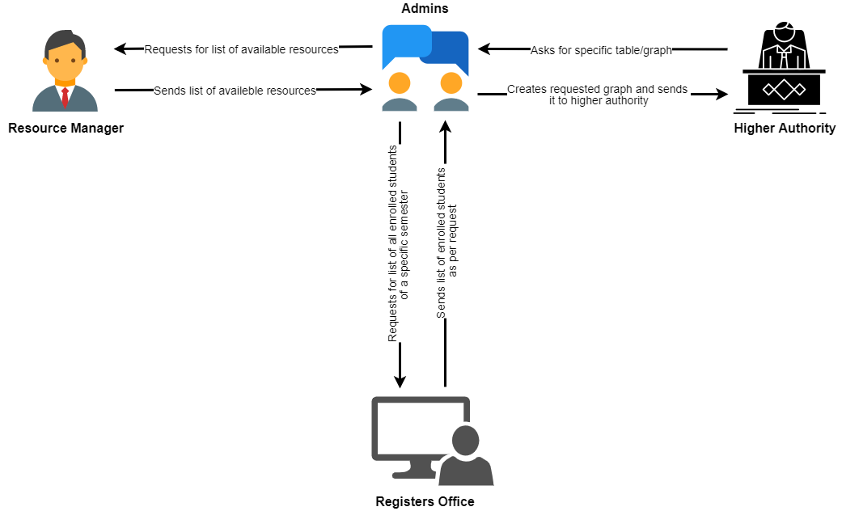

## 

## PROCESSES ALONG WITH SIX SYSTEM ELEMENTS (AS IS)

|  |  |  |  |  |  |  |
| --- | --- | --- | --- | --- | --- | --- |
| **Process** | **Human** | **Non- Computing Hardware** | **Computing Hardware** | **System** | **Database** | **Network/ Communication** |
| **Create different tables and graphs (e.g. Resource Usage Summary,**  **Classroom Requirement Summary, etc)** | **Admin:**  1. Gathers resource-related data from Resource Manager and student registration data from Registers Office respectively.  2. Uses the gathered data to make necessary calculations and creates tables/graphs  **Resource Manager:**  1. Provides resource-related data to Admins.  **Registers Office:**  1. Provides student registration data to Admins. | **Pen and Papers:**  1. Used for noting down relevant information. | **Calculator:**  1. For making necessary calculations  **Computer:**  1. Used for creating Excel Sheets  **Printer:**  1. Can be  used to print  out the generated reports if  needed. | **MS Office:**  1. Used for creating tables/graphs with the gathered data. | **None** | **None** |

## PROCESS DIAGRAM (AS IS)

## EXISTING PROBLEMS & ANALYSIS OF THE PROBLEM

|  |  |  |  |  |
| --- | --- | --- | --- | --- |
| **Process name** | **Stakeholders** | **Concerns** | **Analysis** | **Proposed Solution** |
| Procurement of data | * Admins * Resource Manager * Registers Office | All of the required data has to be collected manually. | Admin has to physically visit the Register's Office and Resource Manager and gather all the spreadsheets containing all the relevant data that is required to make any sort of analysis. | Implement a centralized database where the Resource Managers and Registers Office can upload their corresponding relevant data for each semester, which can be accessed by the admin through the internet. |
| Creating spreadsheets for the analysis | * Admin | Admin has to make the spreadsheets manually using MS Excel | After procurement of data, the admin has to input each and every piece of data manually into MS Excel. Any required Formulas for a row/column have to be provided manually as well. | The procured data in the from of tally sheets can be uploaded into a web-based system which can extract all the data from it and used them to generate meaningful tables/graphs for proper analysis |

## BUSINESS SYSTEM (WITH RICH PICTURE)

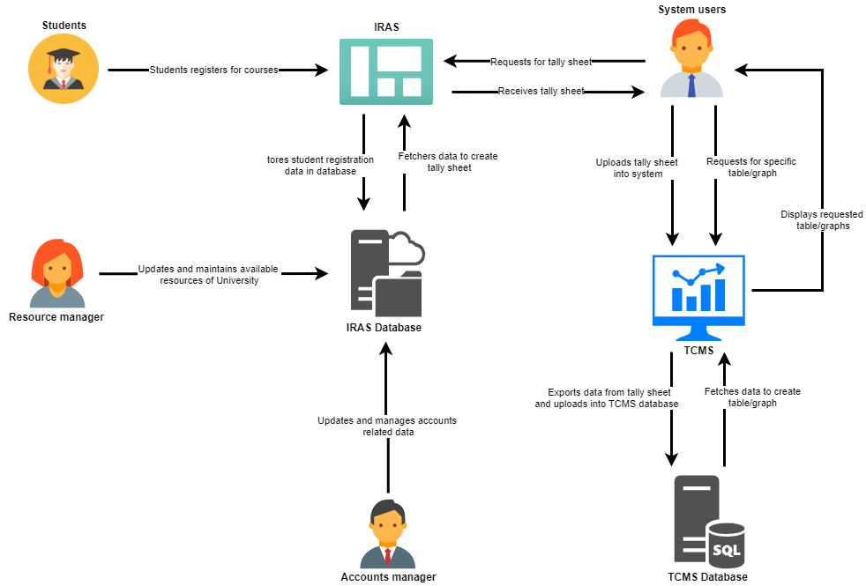

## SIX ELEMENT ANALYSIS (TO BE)

|  |  |  |  |  |  |  |
| --- | --- | --- | --- | --- | --- | --- |
| **Process** | **Human** | **Non-Computing Hardware** | **Computing Hardware** | **Software** | **Database** | **Network/ Communication** |
| **View classroom requirement table & ie chart** | **System user:**  1.Log into TCMS with the correct user id and password.    2. In the dashboard select option to generate graph along with table from a dropdown menu    3. select a semester for which the user wants to view the table and chart. | **Pen and papers:**  It May be used to take any notes | **Computer**:  TO view the table and graph    **Printer:**  Print hard copies of the classroom requirement table | **Operating system:** Used by the users to operate their computer | **My SQL Server:**  1. It stores login credentials for all users  2. used to store the classroom requirement database. | **Internet**: Used to access the TCMS |
| **View Course distribution among the schools table and clustered column graph** | **Human:**  1 .log into TCMS.    2 In the dashboard select comparison section option to generate graph along with table from a dropdown menu    3. Select a semester for which the user want to produce table and chart | **Pen & paper :**    1.Used for take note | **Computer :**  TO view the table and clustered column graph | **Operating system:** Used by the users to operate their computer | **My SQL Server:**  1.It stores login credentials for all users  2. used to store the essential database | **Internet:**  TCMS is a web based application and requires internet access. |
| **Generate table for Resource usage summary** | **System user:**  1. log in to the TCMS with the proper username as a password  2. In the dashboard select option to generate the table of resource usage summaries.  3. Select semester for which to create a table  4. Select  type of table to generate (summarized or non-summarized) | **Pen and Papers:**  1. Used for noting down important points if needed. | **Computers**  1. Used to access the TCMS software.  Printer:  1. Can be used to print out the generated reports if needed. | **TCMS**  1. Fetches resource usage data from the database as per user request and generates tables.  MS Office:  1. Used to store the resource usage summary in excel/spreadsheet after it is generated | **My SQL Server:**  TCMC is integrated with My SQL Server containing records of the usage of all resources throughout all semesters (past and present) | **Internet:**  1. TCMS is a web-based application and required the Internet to access. |
| **Generate table for Resource summary** | **System user:**  1. log in to the TCMS with the proper username as a password  2. In the dashboard select option to generate the table of IUB available resources | **Pen and Papers:**  Used for noting down important points if needed. | **Computers**  1. Used to access the TCMS software.  **Printer:**  1. Can be used to print out the generated reports if needed. | **TCMS**  Fetches resource usage data from the database as per user request and generates tables. | **My SQL Server:**  TCMS is integrated with My SQL Server containing records of the usage of all resources. | **Internet:**  TCMS is a web-based application and requires the Internet to access. |
| **Generate Table/graph for Classroom requirement as per course offerings** | **System user:**  1. log in to the TCMS with the proper username as a password  2. In the dashboard select option to generate the table of Classroom requirements as per the course offering  3. Select semester for which to create a table  4. Select whether to generate graph along with table | **Pen and Papers:**  1. Used for noting down important points if needed. | **Computers:**  1. Used to access the TCMS software.  **Printer:**  1. Can be used to print out the generated reports if needed. | **TCMS:**  1. Fetches data related to available resources and course offerings from the database and uses them to generate tables/graphs  MS Office:  1. Used to store the classroom requirement as per course offering table/graph in excel/spreadsheet after it is generated | **My SQL Server:**  1. TCMS is integrated with My SQL Server containing records of available resources and course offerings throughout all semesters (past and present) | **Internet:**  1. TCMS is a web-based application and requires the internet to access it. |
| **Generate table for Student Enrollment** | **System user:**  1. log in to the TCMS with the proper username and password  2. In the dashboard select option to generate the table of students enrolled starting from 1 and going up to the largest  number in each section | **Pen and Papers:**  Used for noting down important points if needed. | **Computers**  1. Used to access the TCMS software.  **Printer:**  1. Can be used to print out the generated reports if needed. | **TCMS**  Fetches resource usage data from the database as per user request and generates tables. | **My SQL Server:**  TCMS is integrated with My SQL Server containing records of all departments and section enrollment lists. | **Internet:**  1. TCMS is a web-based application and requires the Internet to access. |
| **Generate tables/graphs for higher authority views revenue by the TCMS** | **System User:**  1. Logs into the TCMS with the proper username as a password.  2. Selects range of years and specific semester  3. Views table and charts generated by the system.  4. Select school name from drop down list.  5. View table and charts of specific schools revenue each semester | **Pen and Papers:**  1. Used for noting down important points if needed. | **Computers**  1. Used to access the TCMS software.  **Printer:**  1. Can be used to print out the generated reports if needed. | **TCMS:**  1. Fetches data related to number of students enrolled in each school the following semester from database and uses them to generates table/graph and For viewing revenue related charts | **My SQL Server**  1. Contains the data for the table and charts | **Internet:**  For accessing the proposed system website from outside |
| **Generate table for revenue of departments by SETS** | **System User:**  1. Login to the TCMS with proper username and password  2. In the dashboard select option to generate the revenue of each dept by SETS  3. Select the department of which to create a table.  4. Select to generate a graph along with a table. | **Pen and Paper :**  1. Used for noting down important points if needed. | **Computers:**  1.Used to access the TCMS software.  **Printer:**  1. Can be used to print out the generated reports if needed. | **TCMS:**  1. Fetches data related to available resources from the database and uses them to generate tables/graphs  **MS Office:**  1. Used to store the revenue details as per department to generate tables/graphs in excel/spreadsheet. | **My SQL Server:**  1. TCMS is integrated with My SQL Server containing records of available resources of all departments of SETS (past and present) | **Internet:**  1. TCMS is a web-based application and requires the internet to access it. |

## BUSINESS PROCESS DIAGRAMS (TO BE)

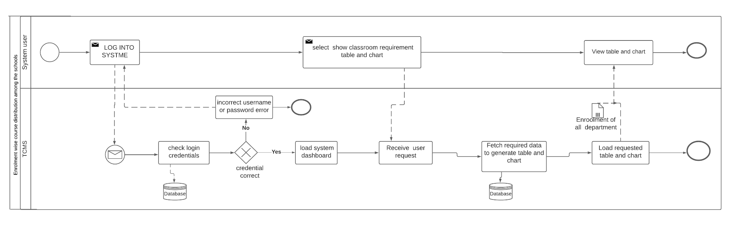

BPMN: Classroom requirement as per course offering (Summary)

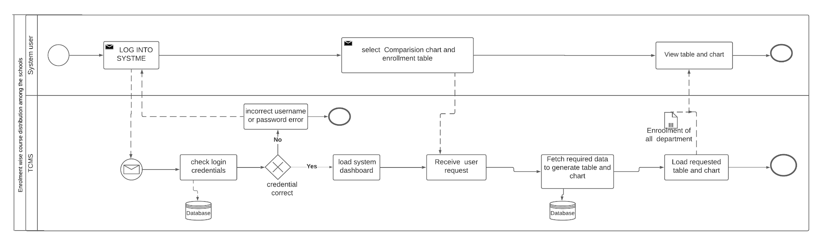

BPMN: Enrolment wise course distribution among the schools

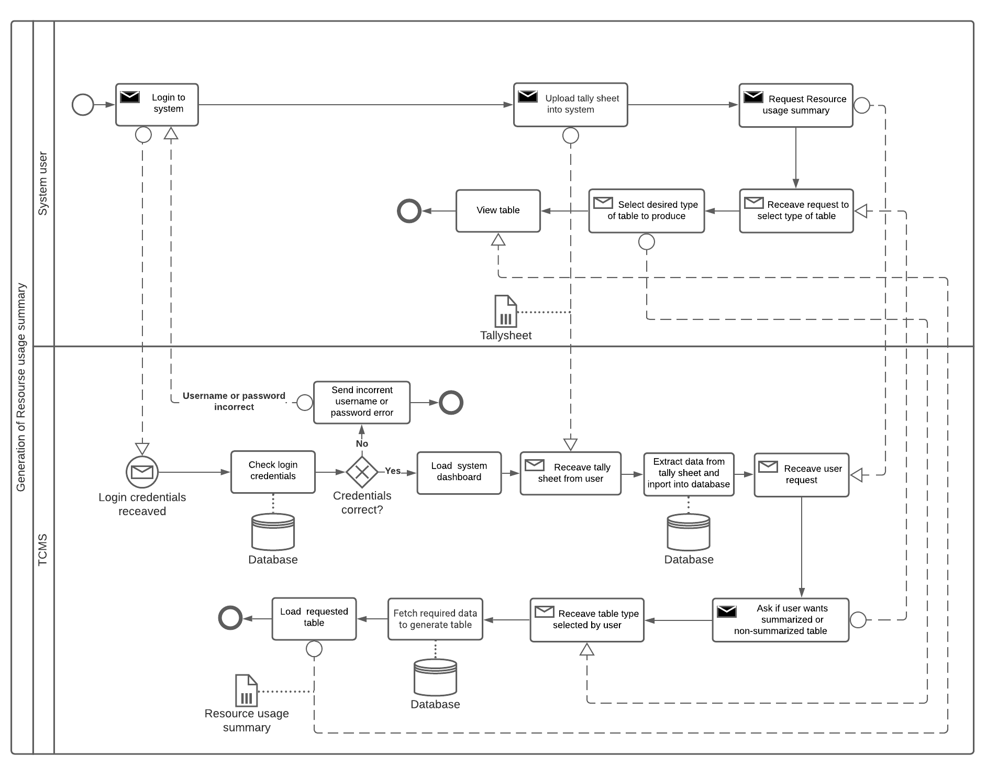

BPMN: Usage of the resources

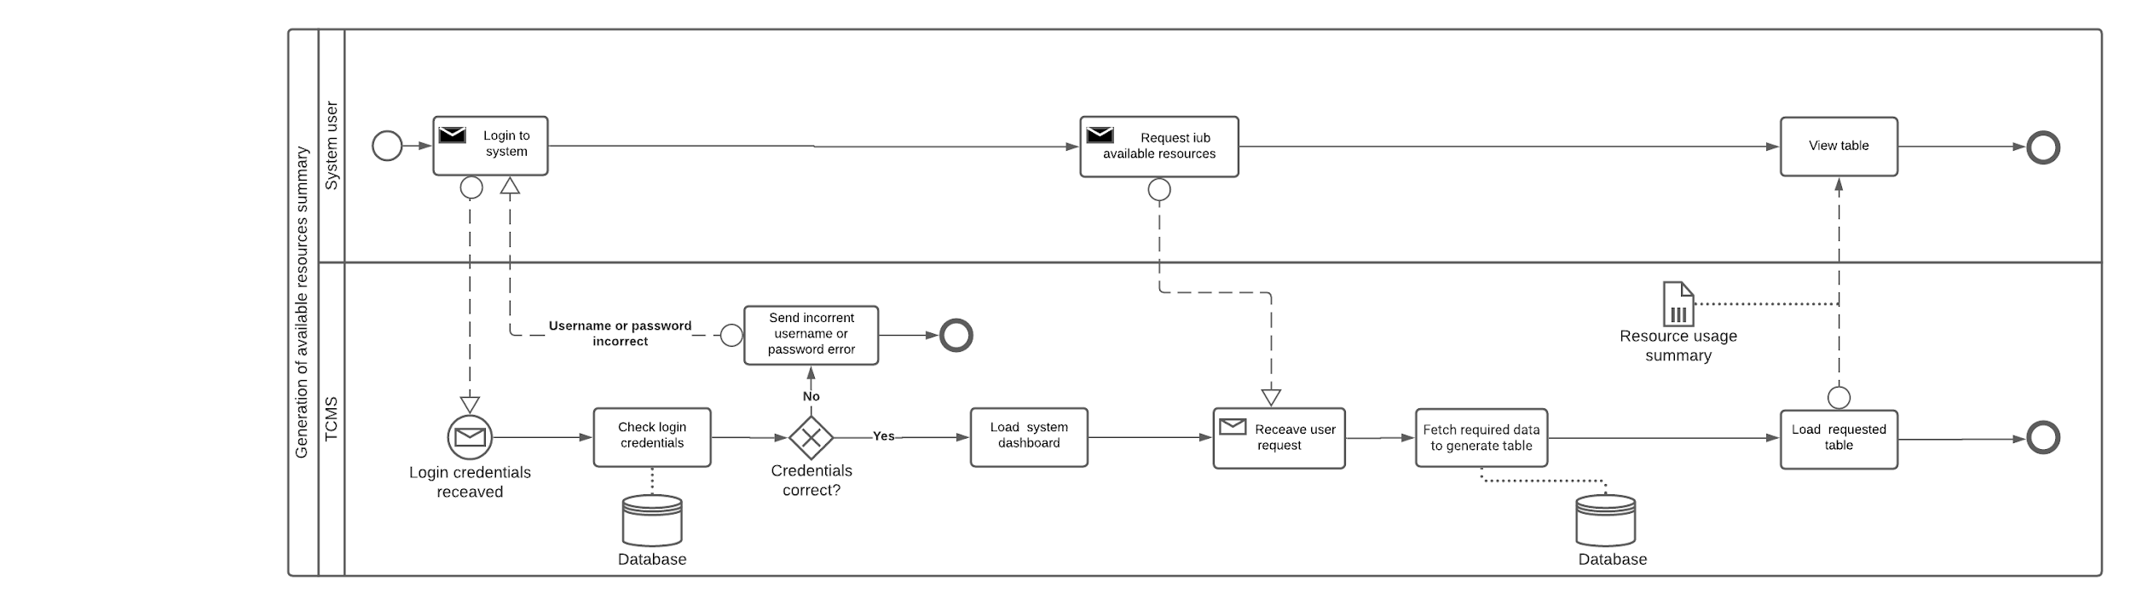

BPMN: IUB available resources

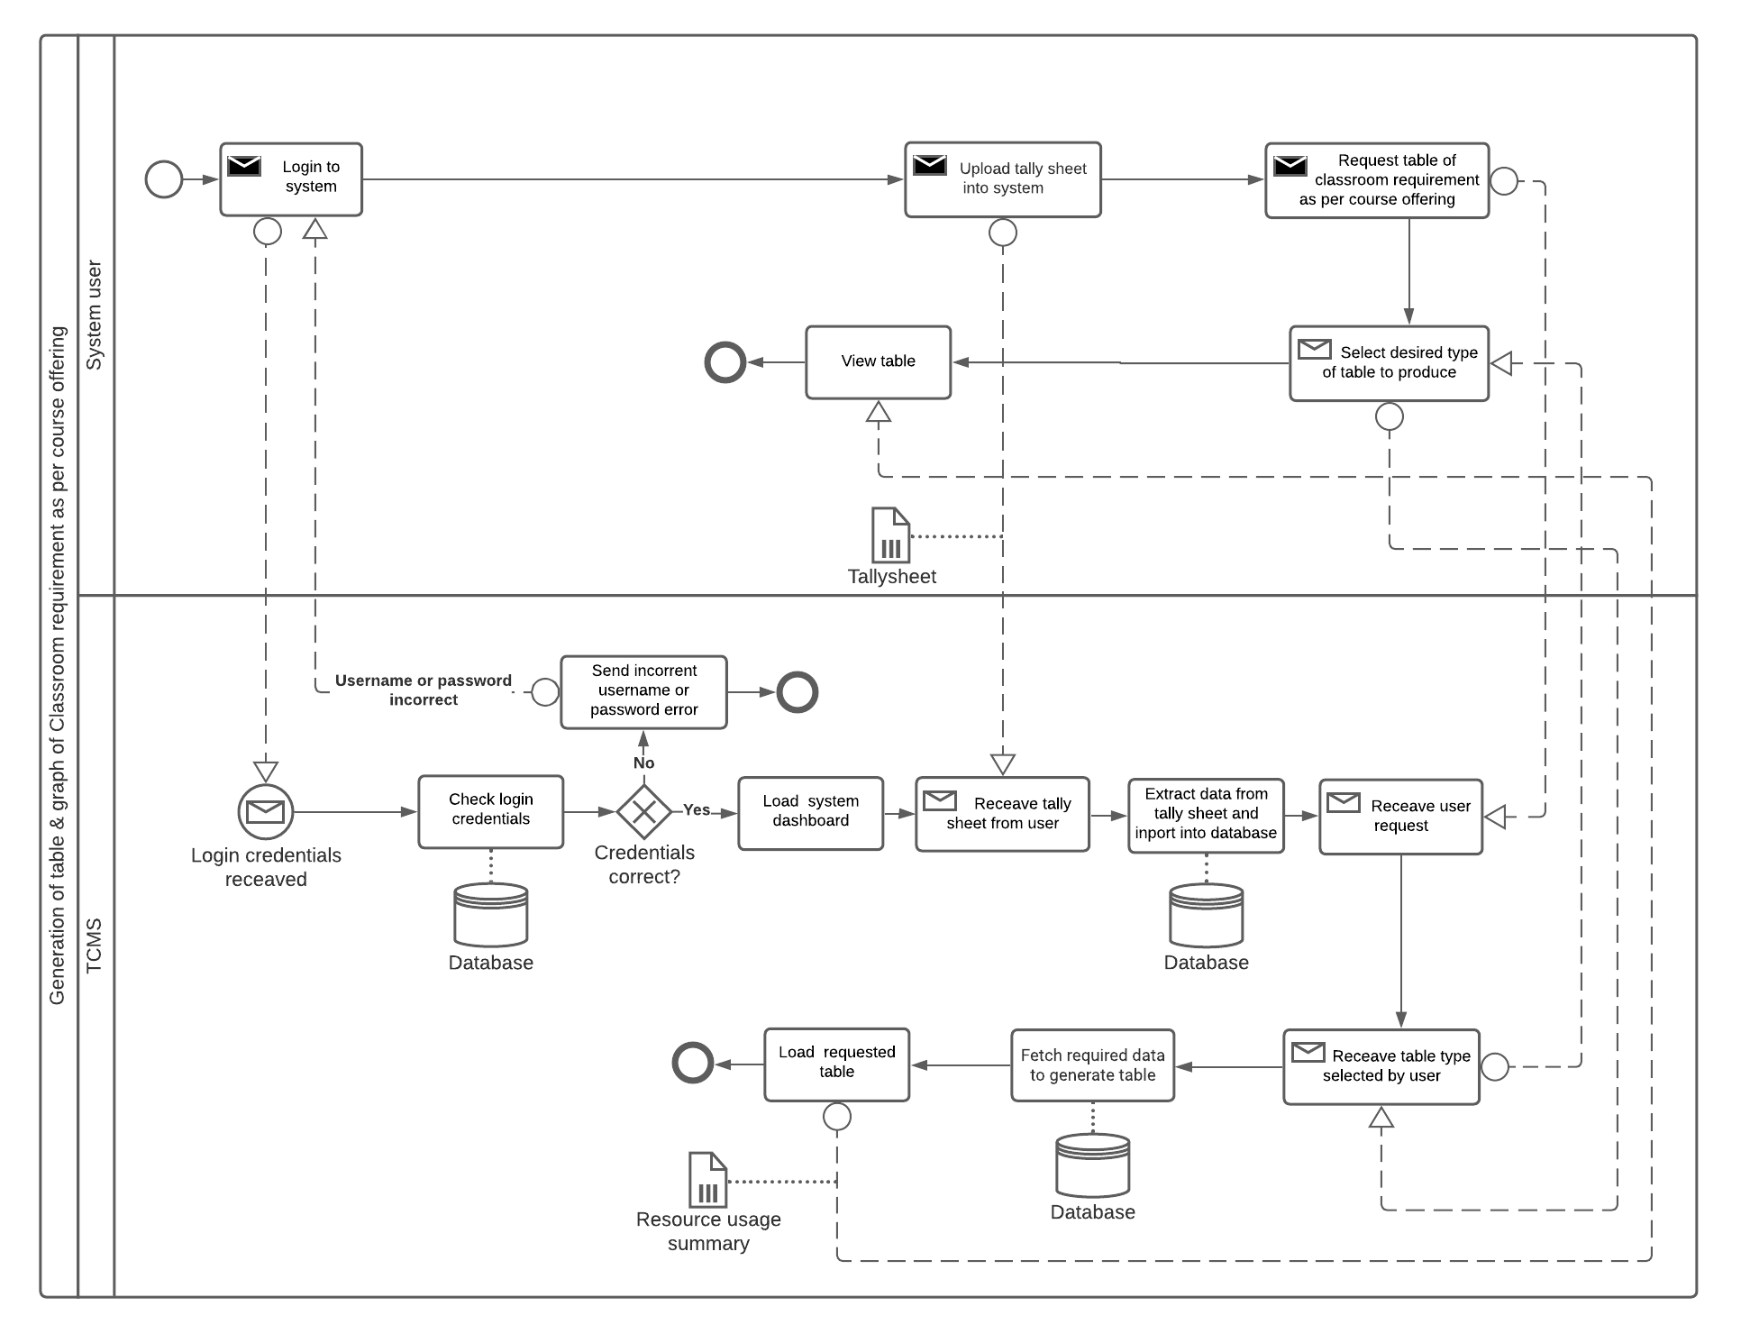

BPMN: Availability and course offering comparison

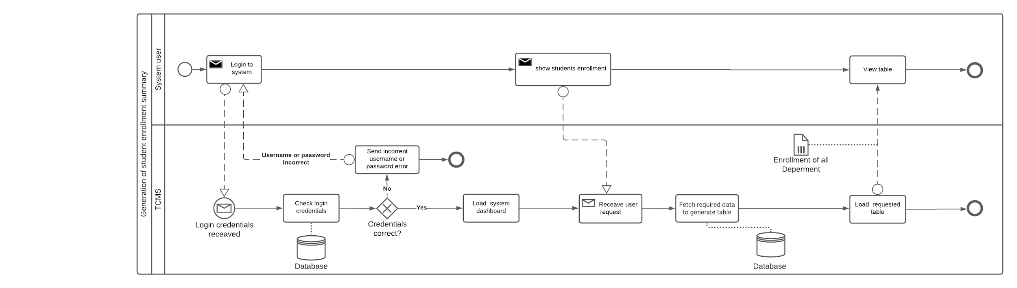

BPMN: Generate table for Student Enrollment

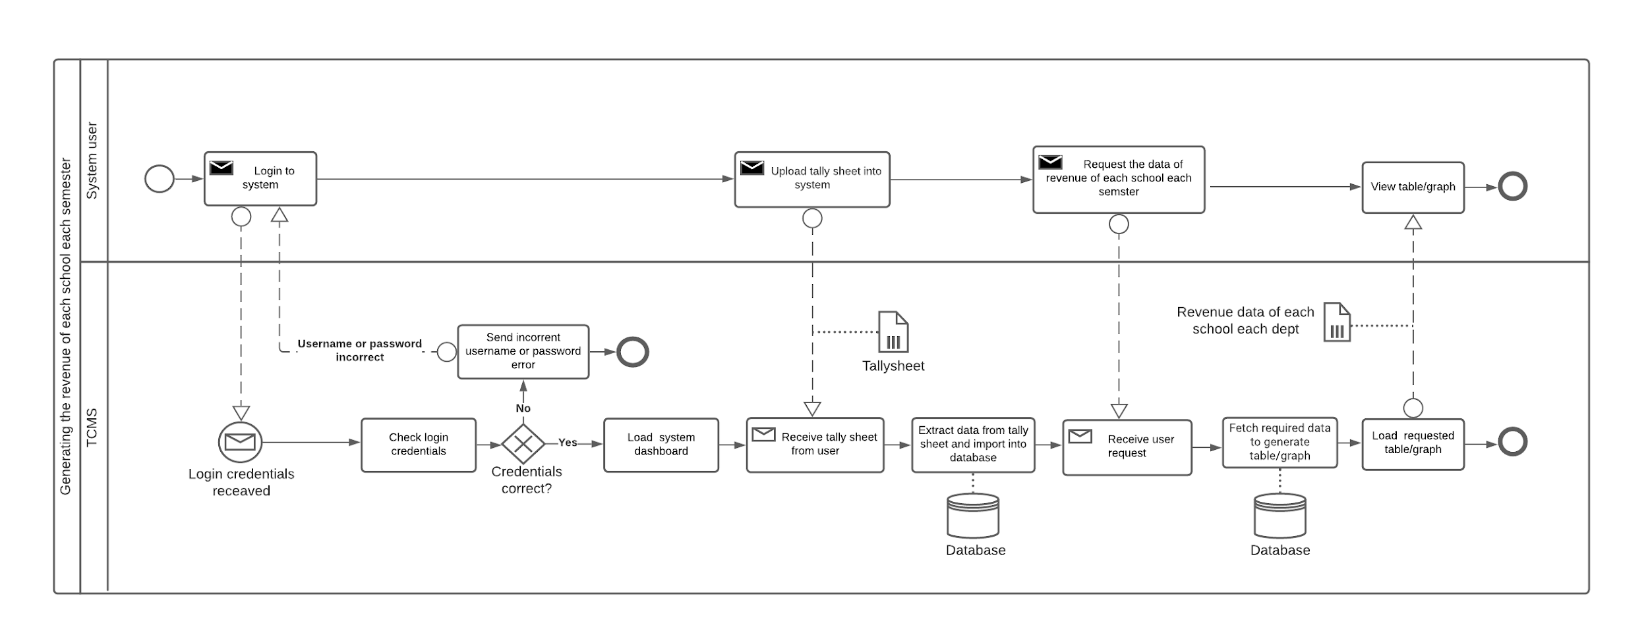

BPMN: Revenue of IUB

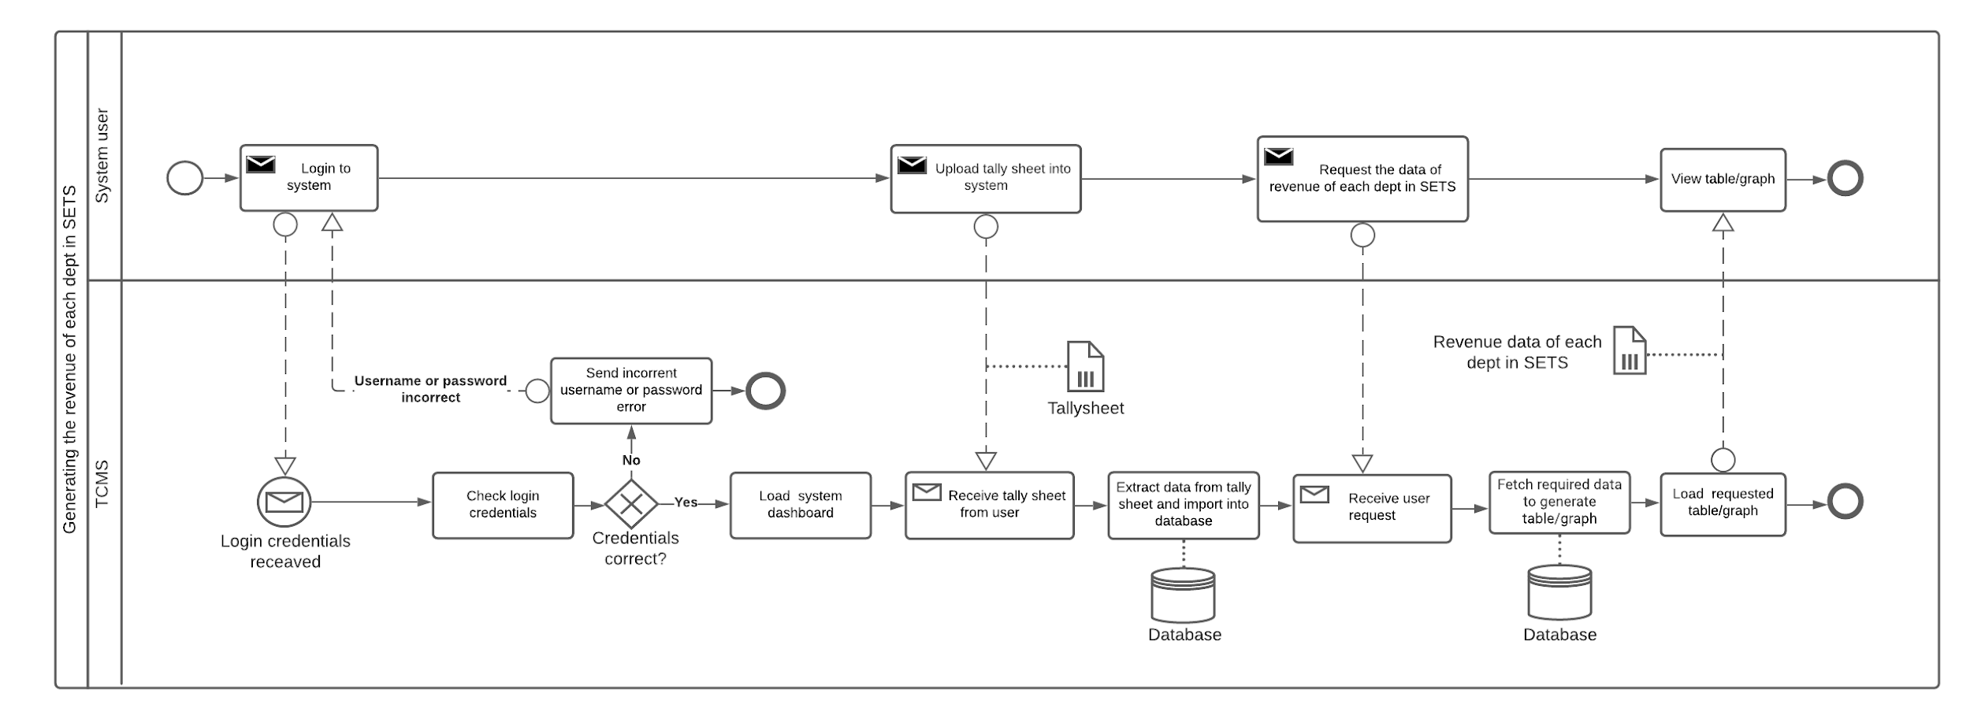

BPMN: Revenue in Engineering School

**CH-3 LOGICAL SYSTEM DESIGN**

BUSINESS-RULES

Business rules describe the operations, definitions, and constraints that govern the data model. As opposed to the ERD, they are made using regular English sentences so that a non-technical A stakeholder can decipher information about the data model without notation knowledge. The business rules that govern our data model are as follows:

Department must offer at least one Course and a Course must belong to exactly one Department. DEPARTMENT includes departmentid, schooltitle

A course must have at least one section and a section is allocated to exactly one course. COURSE contains courseid,DepartmentId, Credit .

A Classroom may be allocated for many sections. A Section is allocated in exactly one Classroom. CLASSROOM includes roomid,roomcapacity. SECTION Includes sectionnumber, semestername, semesteryear ,courseid ,schooltitle ,roomid and studentenrolled.

## ENTITY-RELATIONSHIP DIAGRAM (ERD):

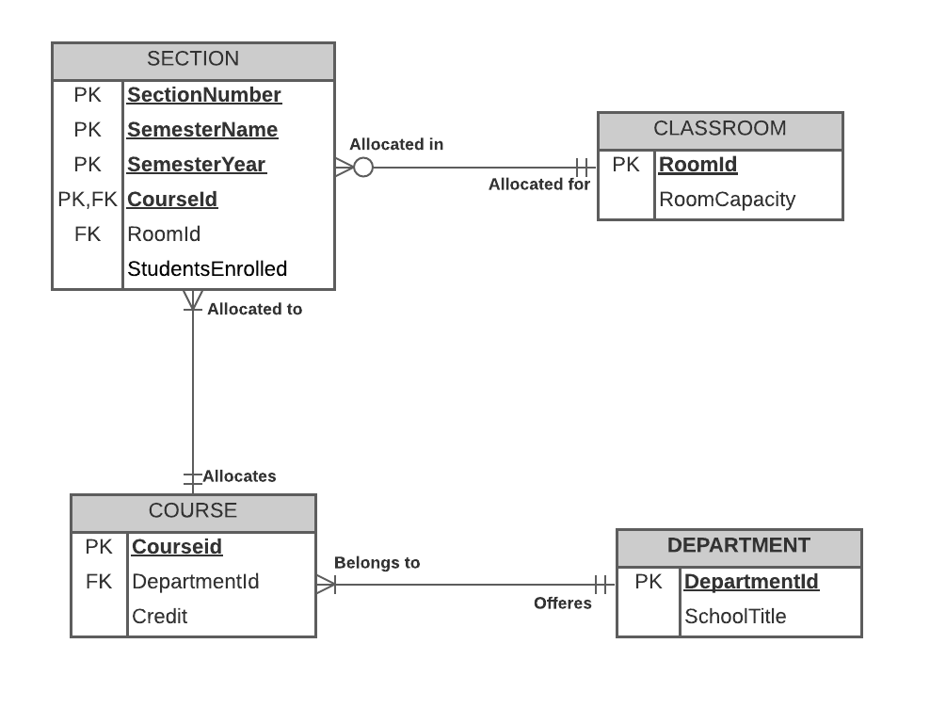

**RELATIONAL SCHEMA**

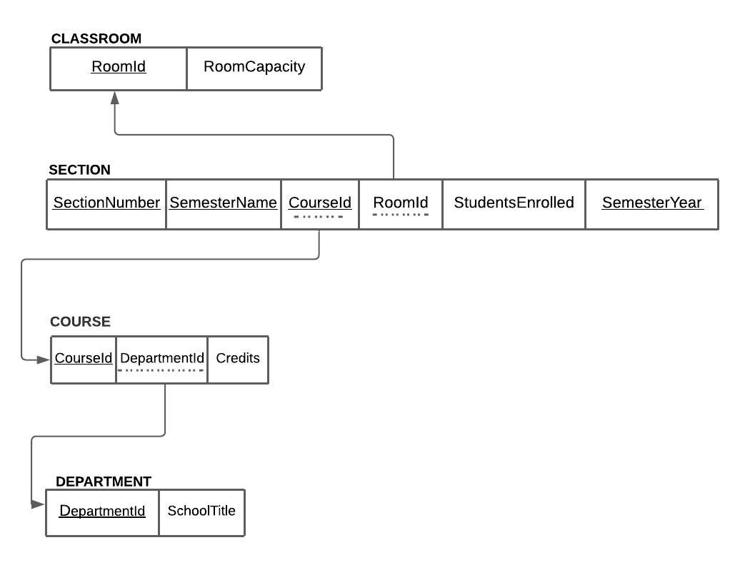

## NORMALIZATION

|  |  |  |
| --- | --- | --- |
| CLASSROOM | RoomId | r1 |
| RoomCapacity | r2 |

|  |  |  |
| --- | --- | --- |
| DEPARTMENT | DepartmentId | d1 |
| SchoolTitle | s1 |

|  |  |  |
| --- | --- | --- |
| COURSE | CourseId | c1 |
| DepartmentId | d1 |
| Credit | c2 |

|  |  |  |
| --- | --- | --- |
| SECTION | SectionNumber | a1 |
| SemesterName | n1 |
| SemesterYear | n2 |
| CourseId | c1 |
| RoomId | r1 |
| StudentEnrolled | a2 |

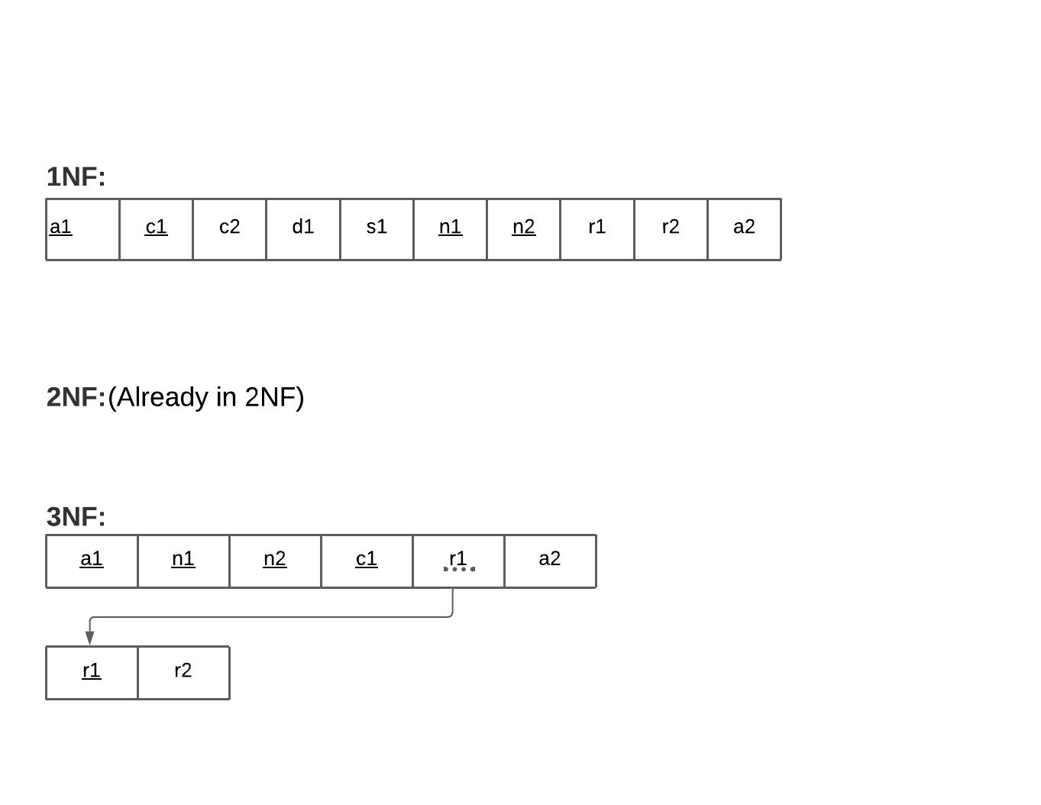

**BCNF:**

No non-key can identify any primary key or part of the primary key. Therefore, all the relations are in BCNF.

## DATA DICTIONARY

Classroom_T

|  |  |  |  |
| --- | --- | --- | --- |
| Name | Data Type | Size | Remarks |
| croom_id | VARCHAR | 11 | This contains the number of the classroom. Ex: “Room no: BC2002” |
| nroom_capacity | INTEGER | 3 | This contains the number of students that can be allocated in a classroom. Ex: “45” |

Section_T

|  |  |  |  |
| --- | --- | --- | --- |
| Name | Data Type | Size | Remarks |
| nsection_number | INTEGER | 2 | This is the Primary Key for the Section.  Ex: “1” |
| csemester_name | VARCHAR | 6 | This is the semester of the section.  EX: “Spring” |
| ccourse_id | VARCHAR | 6 | This is the Primary Key for the Course.  Ex: “CSE464” |
| csemester_year | INTEGER | 4 | Ex: “2021” |
| croom_id | varchar | 15 | Ex: “BC5002” |
| nstd_enrolled | int | 3 | Ex: “50” |

Course_T

|  |  |  |  |
| --- | --- | --- | --- |
| Name | Data Type | Size | Remarks |
| cdepartment_id | VARCHAR | 3 | This is the DepartmentID of the  Department. Ex: “CSE” |
| cccourse_id | VARCHAR | 6 | This is the Primary Key from the Section table. Ex: “CSE464” |
| nCredits | INTEGER | 1 | This is the number of credits per course. Ex: 3 |

Department_T

|  |  |  |  |
| --- | --- | --- | --- |
| Name | Data Type | Size | Remarks |
| cdepartment_id | VARCHAR | 3 | This is the DepartmentID of the  Department. Ex: “CSE” |
| cschool_title | VARCHAR | 5 | This is the primary key of School.  Ex: “SETS” |

**CHAPTER 5 - CONCLUSION:**

**A. PROBLEM AND SOLUTION:**

Analysis Phase

During the analysis phase conceptualization was made on how to improve the existing system. While working on the Rich Picture and Six Element Analysis of operations of the organization, simultaneously, assumptions for the queries required to make the project were made. Interviews with faculty members and senior students were done for better understating of the project.

Designing Phase

Upon further research all entities related the project were created and the relation between all entities were defined. which was also introduced in the Relational Schema schematic. Feedback from course instructor also played a very valid and crucial role in this phase.

Implementation Phase

All software requirements were reached. Deliverables 1,2,3,4 and 5 were achieved.

Front-End Developing tools: HTML, CSS, Bootstrap JavaScript

Back End Developing tools: Raw PHP

Database-integration: MySQL

**B. ADDITIONAL FEATURE AND FUTURE DEVELOPMENT:**

Future Developing Purposes:

* Add feature to automatically generate optimal classroom allocation based on number of students enrolled in a particular course for a particular semester.
* Deployment.